Amazon Elastic Compute Cloud-EC2

Amazon Elastic Compute Cloud (Amazon EC2) **is a web service that provides resizable compute capacity in the cloud. It is designed to make web-scale computing easier for developers.** Amazon EC2's simple web service interface allows you to obtain and configure capacity with minimal friction.

There are 2 types of environments provided by EC2

* Virtual servers
* Bare mental servers

EC2 Focus: - Manage the Remote infrastructure management (RIM)

1. **Virtual Servers: -**

Operating System: - a) Linux (SSH)

b) Windows (RDP)

1. **Bare metal Servers :-**

Hardware :- Remote Console / Serial Console/Management Console/

Integrated Life Out

**Which hardware**: - Switches, Firewall, Routers, Network Device

**Advantages:-**

* It is flexible
* Very less Provisioning Time
* It is Cheap – Rent – pay as you go
* Elasticity (Increase/Decrease/Size)
* Secure
* Alter my capacity
* Web server (Zonal Service)
* Purchase Option is available
* Completely controlled by your own instances
* Flexible Cloud hosting service

**Dis-Advantages:-**

* Price Variations
* Limitations
* General Issue
* Conclusion

3 Types of Purchasing ec2

1. On Demand Instances– Tatkal Reservation (The Most Flexible. ...)
2. Reserve Instances – Advance Reservation (Built for Predicted Scalability. ..)
3. Spot Instances – Happy hrs.(The Deepest Discount.)

**On-Demand Instances**

This is the most basic, least complicated way to provision Amazon EC2 Instances. It’s the pay-as-you-go model. On-Demand EC2 Instance purchasing is also the most expensive way to provision resources. If you’re running an EC2 workload at scale, managing all of your instance provisioning on an On-Demand basis would get quite expensive.

**Reserved Instances**

Reserved Instance (RI) purchases are one of the easiest ways to start reducing cloud spends. When you buy an RI, you are “reserving” that instance for a one or three-year period. In return for that long-term commitment, AWS gives a hefty discount of up to 72% off compared to the On-Demand prices. [Managed Service Providers](https://cloudcheckr.com/solutions/managed-service-providers/) may find RI purchasing to be the most economical option for increasing profits while adding value for their customers. If your needs change, Standard RIs can be resold on the AWS RI Marketplace or Convertible RIs can be exchanged for RIs of a comparable value but cannot be resold.

**Spot Instances**

Spot Instances allow you to take advantage of Amazon’s ‘extra’ capacity. They are offered at a deep discount of [up to 90% off](https://aws.amazon.com/ec2/spot/) the On-Demand EC2 prices. The catch is that you don’t actually reserve them. If someone else requests to use those instances, you’ll be disconnected after a two-minute warning.

Spot Instances are not great for customer-facing, time-sensitive use cases, or for applications that can’t be interrupted — like an e-commerce website. However, most businesses have some workloads that can be interrupted and are not time sensitive. If you’re running any workloads that fit those requirements, Spot Instances are an option for reducing costs substantially.

**Savings Plans**

AWS Savings Plans provide discounts for one or three years of committed usage, measured in dollars per hour of compute power. The EC2 Instance Savings Plan (one of three types offered) helps you purchase Amazon EC2 Instances at a significant discount of up to 72%. With this type of Savings Plan, you commit to an EC2 Instance family and region, but you have the flexibility to change instance size and operating systems. You can achieve discounts of up to 66% with a Compute Savings Plan, which allows for usage across Amazon EC2 instance types and regions, and also provides discounts for AWS Lambda and AWS Fargate.

Tenancy Model of EC2 :-

1. Shared – Different Instances in one EC2
2. Dedicated Instance – Same Instances in one EC2
3. Dedicated Host – Whole Instance is yours

**Shared:-**

Whenever we create EC2 instances, we are using Shared Tenancy by default.

* In Shared tenancy, single host machine can have instances from multiple customers.

**Dedicated Instance:-**

EC2 Dedicated Instances are Virtualized instances on hardware dedicated to one customer:

* You do NOT have visibility into the hardware of underlying host

**Dedicated Host:-**

EC2 Dedicated Hosts are Physical servers dedicated to one customer:

* You have visibility into the hardware of underlying host (sockets and physical cores)
* 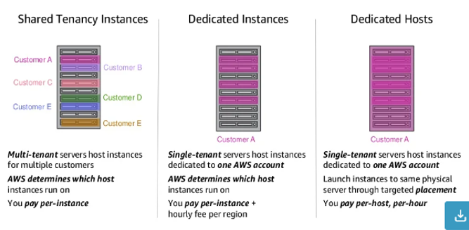(Use cases) Regulatory needs or server-bound software licenses like Windows Server, SQL Server

**Structure:-**

EC2 Hardware Configuration:-

Amazon EC2 provides a wide selection of instance types optimized to fit different use cases. Instance types comprise varying combinations of CPU, memory, storage, and networking capacity and give you the flexibility to choose the appropriate mix of resources for your applications. Each instance type includes one or more instance sizes, allowing you to scale your resources to the requirements of your target workload.

All instances have the following specs: **Intel AVX†, Intel Turbo†** t2.nano, t2.micro, t2.small, t2.medium have up to 3.3 GHz Intel Xeon Scalable processor. t2.large, t2.xlarge, and t2.2xlarge have up to 3.0 GHz Intel Scalable Processor.

The Amazon Elastic Compute Cloud (EC2) is an infrastructure as a service (IaaS) cloud. This means that it provides computing power and resources that you can use for a fee. You take care of running the software**; Amazon EC2 provides the hardware.**

**T – Tinny** *t2 Micro-free service*

**G – General Purpose**

**M – Medium**

**C – Compute optimize**

**R – Memory Optimize**

**D – Disc Optimize**

**P – CPU Optimize**

**X – Extra Large (4096 CPU, 4 TB RAM, 40 GBPS Nic)**

What is a burstable instance?

A burstable instance is a virtual machine (VM) instance that provides a baseline level of CPU performance with the ability to burst to a higher level to support occasional spikes in usage. Many general purpose workloads are on average not busy, and do not require a high level of sustained CPU performance. The following graph illustrates the CPU utilization for many common workloads that customers run in the AWS Cloud today.


         Many common workloads look like this: the average CPU utilization is at or below
            the baseline, with some spikes above the baseline.
      These low-to-moderate CPU utilization workloads lead to wastage of CPU cycles and, as a result, you pay for more than you use. To overcome this, you can leverage the low-cost burstable general purpose instances, which are the T instances.

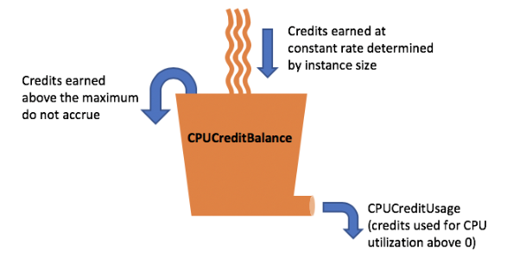Its look like Credit, if you cannot use it for any object it will store & allow you to use for next project if required as reserve credit.

* **This is default service for all instance & you can just enable the option.**

2 BY 2 Checks (Hardware & Hypervisor)

When an EC2 instance is launched, AWS checks whether that ec2 is able to connect to the network or not. It does so in two steps.

Step 1: **System check,** this checks for proper hardware configuration of the instance at host level. It should be noted that you cannot check these. These are aws managed. The best you can do is just stop and start the Instance in case system checks fail. It simply deallocates the previous VM and a new VM on different hardware is provisioned. If you want to retain public IP and other related stuff, you can configure Auto Recovery of instance from cloudwatch console.

Step 2: **Instance check**, this check is done to check software (Operating System) level configuration of the instance. This can be looked into by you. If this check fails, then you will need to check either user data/ launch configuration or AMI/OS configuration.

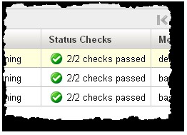

When instance 2/2 working its shows like below - As both status checks as green as 2/2 checks passed.

**Benefits :-**

* Give you the good & healthy hardware
* You can monitor the instance failure & where it happens
* You can try to fix the failure by own or reaching out to AWS with correct guideline

# AWS Key Management Service (Key Concept)

AWS Key Management Service (AWS KMS) is a managed service that makes it easy for you to create and control the cryptographic keys that are used to protect your data.

AWS KMS is supported in regional only & create the multi-regional keys, which is act as like copies of the same KMS key in different AWS Region.

If your data (Packets) send from the computer/laptop to AWS that data should be in text format & hacker can easily hack the credentials avoid this, we are used below 2 tools

* **Sniffing attack -** Sniffing attack in context of network security, corresponds to theft or interception of data by capturing the network traffic using a packet sniffer.
* **Wireshark -** Wireshark is a free and open-source packet analyzer. It is used for network troubleshooting, analysis, software and communications protocol development, and education.

There are major 2 types of keys are using for AWS infra to secure the user login

1. Public key
2. Private key

[**Private Key**](https://www.geeksforgeeks.org/digital-signatures-certificates/)**:** In the Private key, the same key (secret key) is used for encryption and decryption. In this key is symmetric because the only key is copied or shared by another party to decrypt the cipher text. It is faster than public-key cryptography.

[**Public Key**](https://www.geeksforgeeks.org/public-key-encryption/)**:** In a Public key, two keys are used one key is used for encryption and another key is used for decryption. One key (public key) is used to encrypt the plain text to convert it into cipher text and another key (private key) is used by the receiver to decrypt the cipher text to read the message.

[**Cryptography**](https://www.geeksforgeeks.org/cryptography-introduction-to-crypto-terminologies/)is the science of secret writing with the intention of keeping the data secret. Cryptography is classified into symmetric cryptography, asymmetric cryptography, and hashing.

We send the data in encryption format & domain can decrypt the data, called this process [Cryptography](https://www.geeksforgeeks.org/cryptography-introduction-to-crypto-terminologies/) (PKI)

PKI stands for – Private Key & Public Key

If AWS send the data to us they give us the private key & when we create the data AWS also suggested to save the private key so data should be secure for all time.

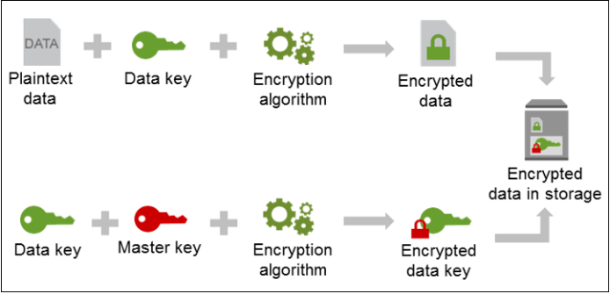

**Important Notes: -**

Make sure we can save (keep) the private key with us & share the public key.

In AWS private key are used in ***.pem*** format for us.



Below are the services to import the IPM AWS.

**Linux Machine** – [Cloud-init service responsible to put public IP in AWS instance](https://cloud-init.io/)

**[Windows Machine](https://cloud-init.io/)** [– EC2 config (2016 till)](https://cloud-init.io/)

Launch EC2 Config (2017 onward)

**PKI Infrastructure:-**